***AURA LATHER WATCH:***

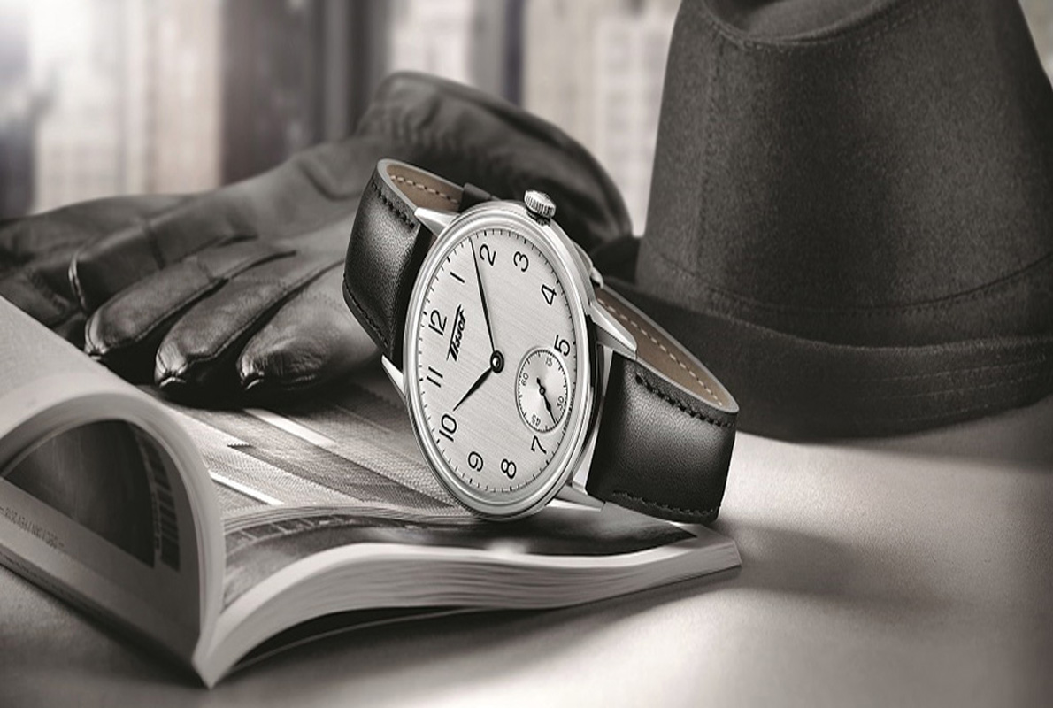

***DETAILS ABOUT THIS WATCH:***

Movement: Miyota Japanese quartz 3 hand.  
Dial: The dial includes bold printed numbers and indices, printed seconds track, and custom molded hands with luminous fill.  
Case: 42 mm, 100 meter, custom solid stainless steel case, solid stainless steel fixed bezel, hardened mineral crystal, triple gasket stainless crown with enamel fill, solid stainless steel screw ***SPACES:***

**MOV'T TYPE:**Quartz

**STRAP MATERIAL:**Leather

**CASE SHAPE:**Round

**WATER RESISTANCE:**10 ATM

**DIAL COLOR:**Black

***Price:***

***Rs:1,000***